*/* 1 */*

*/* 1 */*

DATA class;

INPUT  Name $ Sex $ Date_of_birth DATE9. Height Weight;

IF Date_of_birth < '01JAN2001'd;

DATALINES;

Alfred M 25OCT2001 72.0 122.5

Alice F 06APR2000 63.5 112.0

Carol F 14MAY1998 62.8 99.5

James M 21MAR2000 66.3 99.5

Jane F 02DEC2000 61.8 94.5

Janet F 15JUL1999 68.5 118.5

;

PROC PRINT DATA = class;

FORMAT Date_of_birth MMDDYY8.;

TITLE 'class data';

RUN;

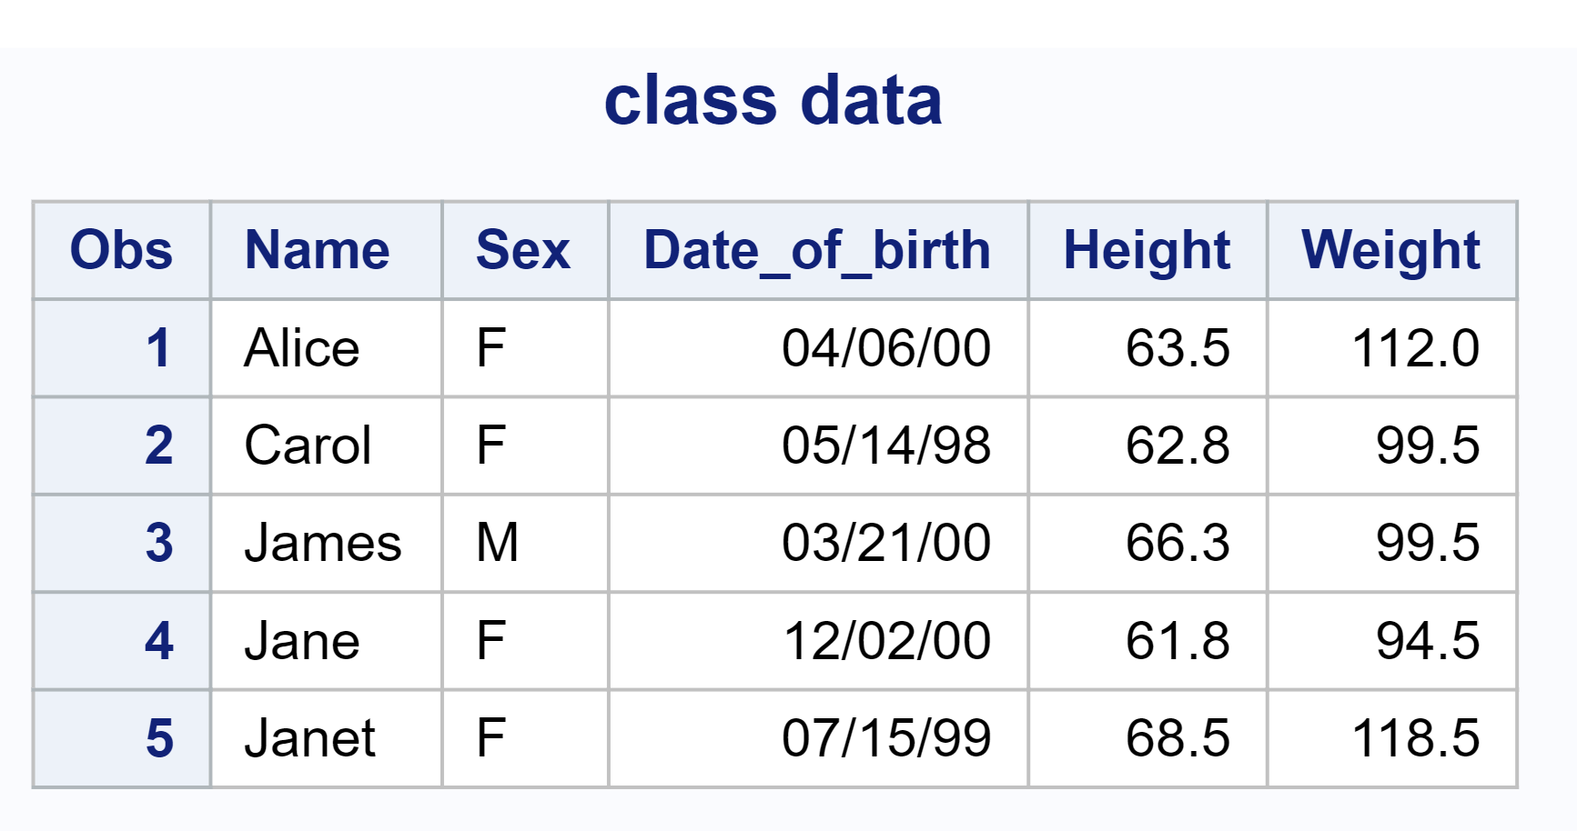

*/* 2 */*

PROC PRINT DATA = class;

WHERE Weight < 100;

FORMAT Date_of_birth MMDDYY8.;

TITLE 'class data where weight'

RUN;

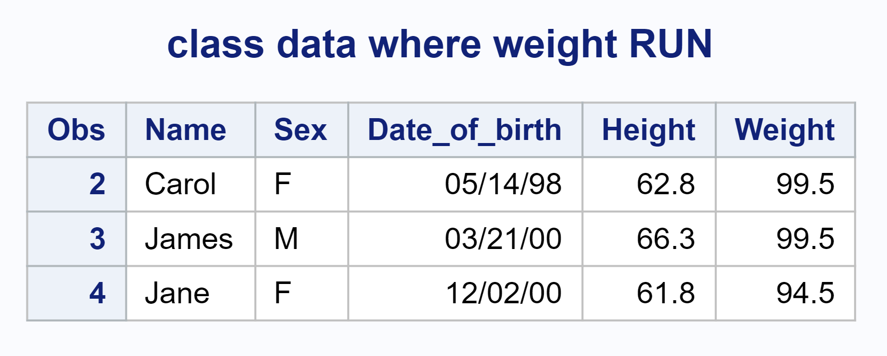

*/* 3 */*

DATA class_all;

INPUT  Name $ Sex $ Date_of_birth DATE9. Height Weight;

IF Date_of_birth < '01JAN2001'd;

DATALINES;

Alfred M 25OCT2001 72.0 122.5

Alice F 06APR2000 63.5 112.0

Carol F 14MAY1998 62.8 99.5

James M 21MAR2000 66.3 99.5

Jane F 02DEC2000 61.8 94.5

Janet F 15JUL1999 68.5 118.5

;

PROC SORT;

    BY DESCENDING Weight Name;

PROC PRINT DATA = class_all;

TITLE 'class data desc weight';

FORMAT Date_of_birth MMDDYY8.;

RUN;

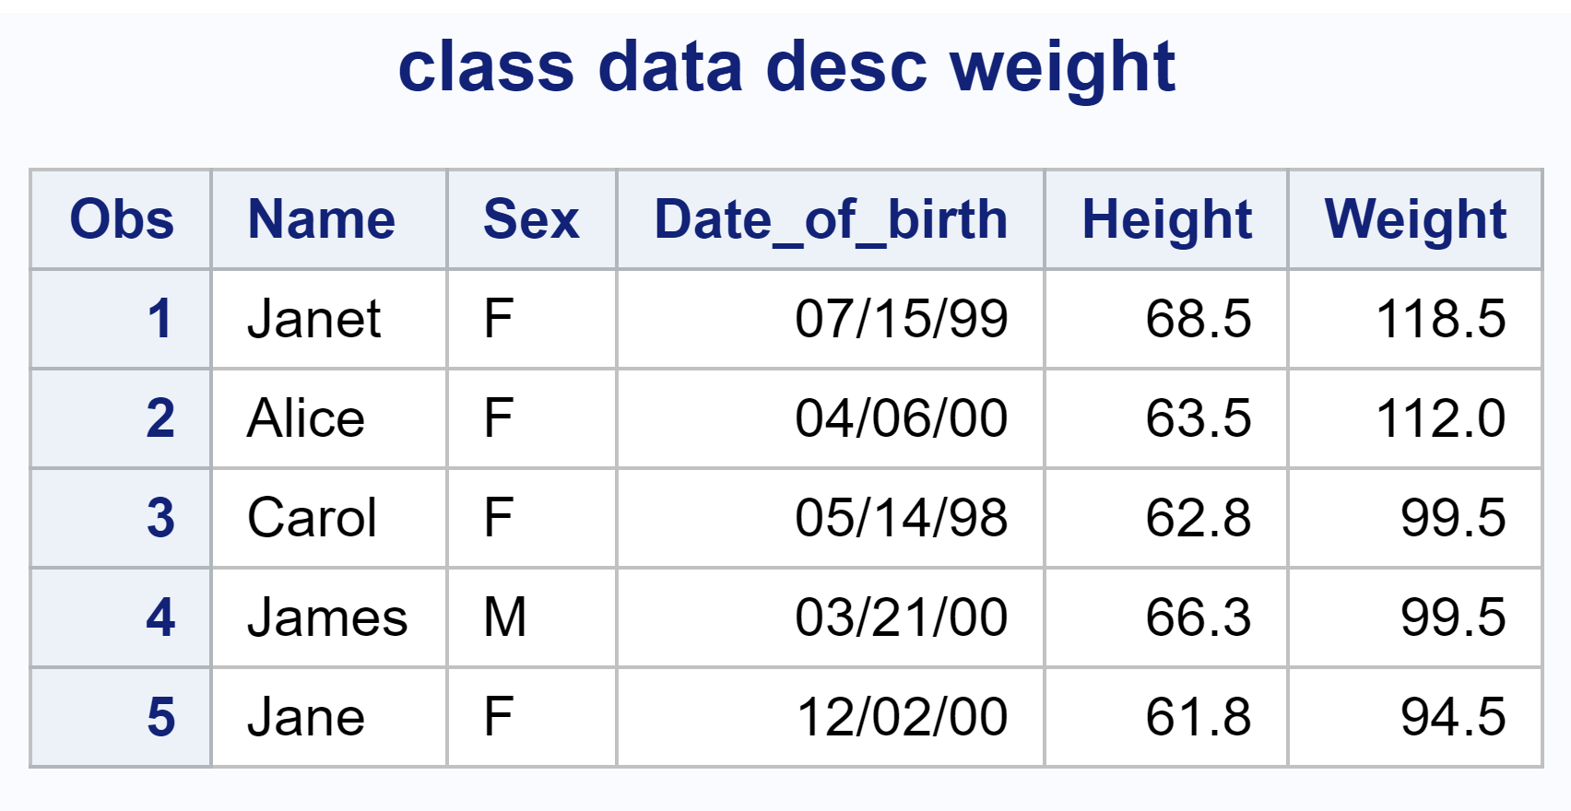

*/* 4 */*

PROC MEANS NOPRINT DATA = class_all;

    class Sex;

    VAR Height Weight;

    OUTPUT OUT = newclass MEAN(Height Weight) = mheight mweight

        SUM(Height Weight) = mheight mweight;

PROC PRINT DATA = newclass;

TITLE 'new class data';

FORMAT mheight mweight 2. Date_of_birth MMDDYY8.;

RUN ;

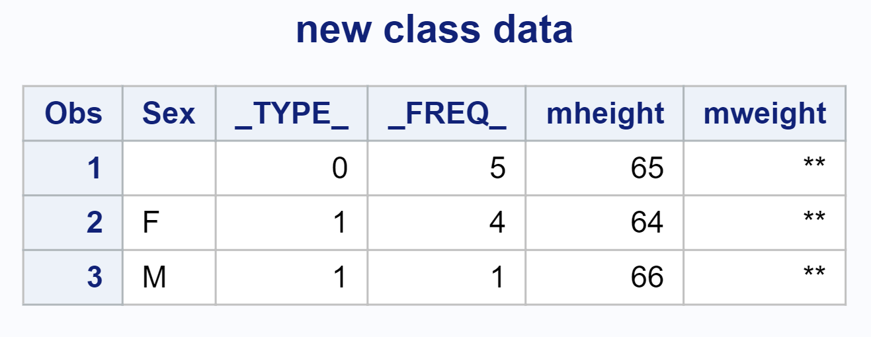

*/* 2 */*

*/* 1 */*

DATA samples;

INPUT rating @@;

diff = rating - 87;

DATALINES;

87.5 86.9 86.6 87.3 87.9 88.0 86.7 87.5 87.2 87.0 88.1 87.5 86.5 87.7 88.0 87.1 87.0 87.6 87.5 88.3

;

PROC UNIVARIATE DATA = samples Normal;

VAR diff;

RUN;

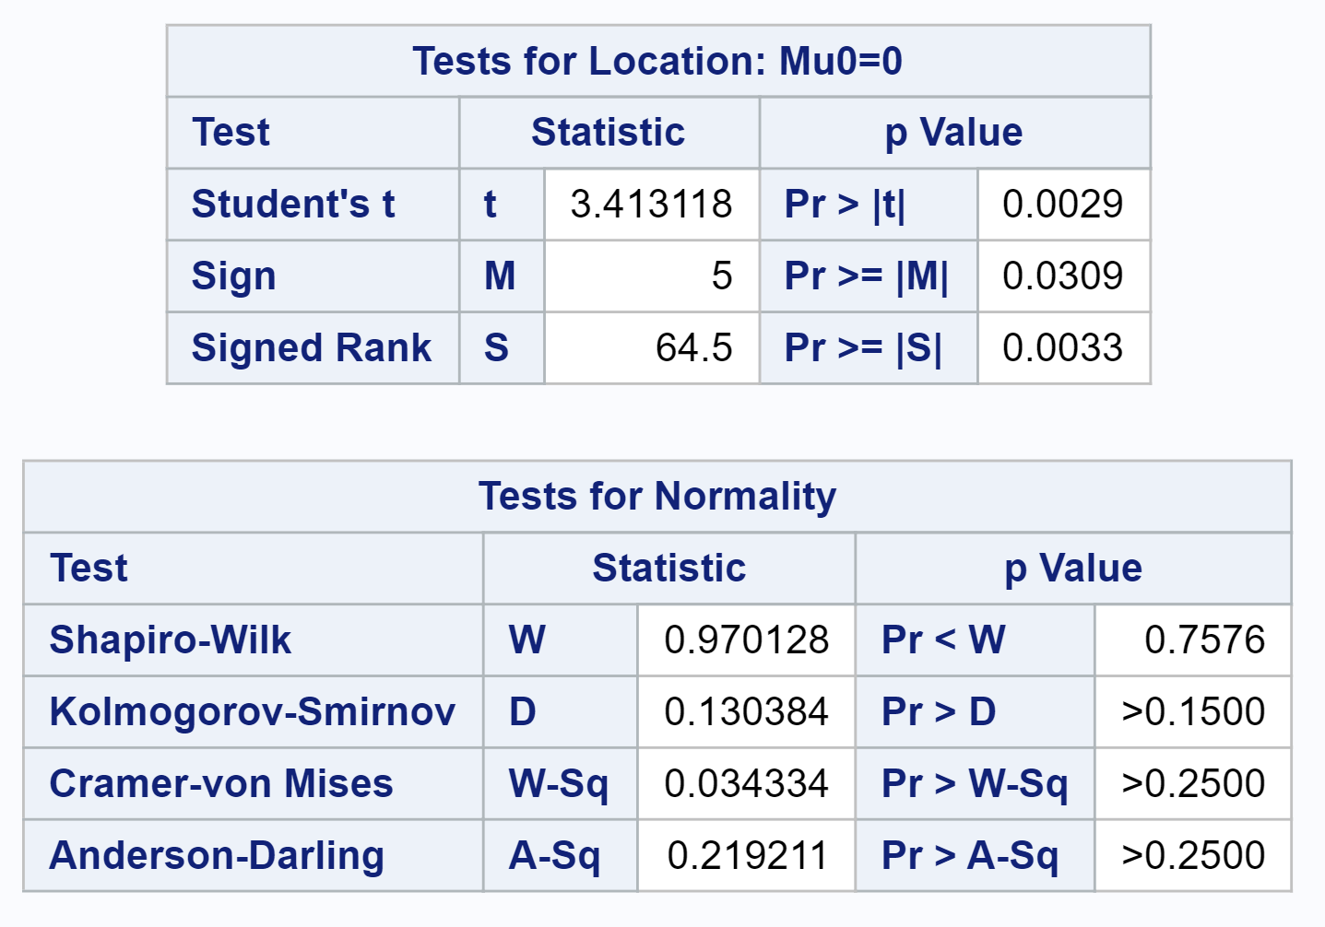

*/* 2 */*

PROC TTEST DATA = samples SIDES = U ALPHA = 0.1;

VAR diff;

RUN;

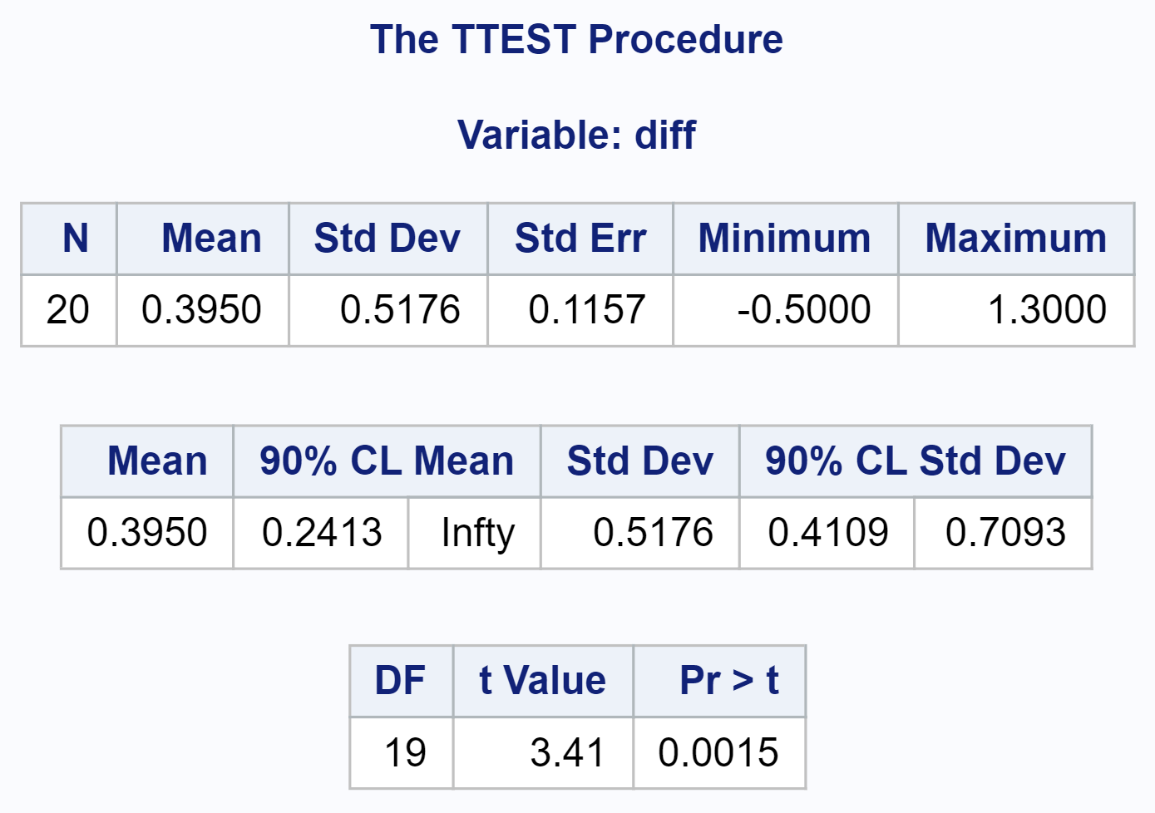

*/* 3 */*

DATA tobacco;

input leaf virus1 virus2;

diff = virus1 - virus2;

DATALINES;

1 31 18

2 20 17

3 18 14

4 17 11

5 09 10

6 08 07

7 10 05

8 07 06

9 11 09

;

PROC UNIVARIATE data = tobacco normal;

VAR diff;

RUN;

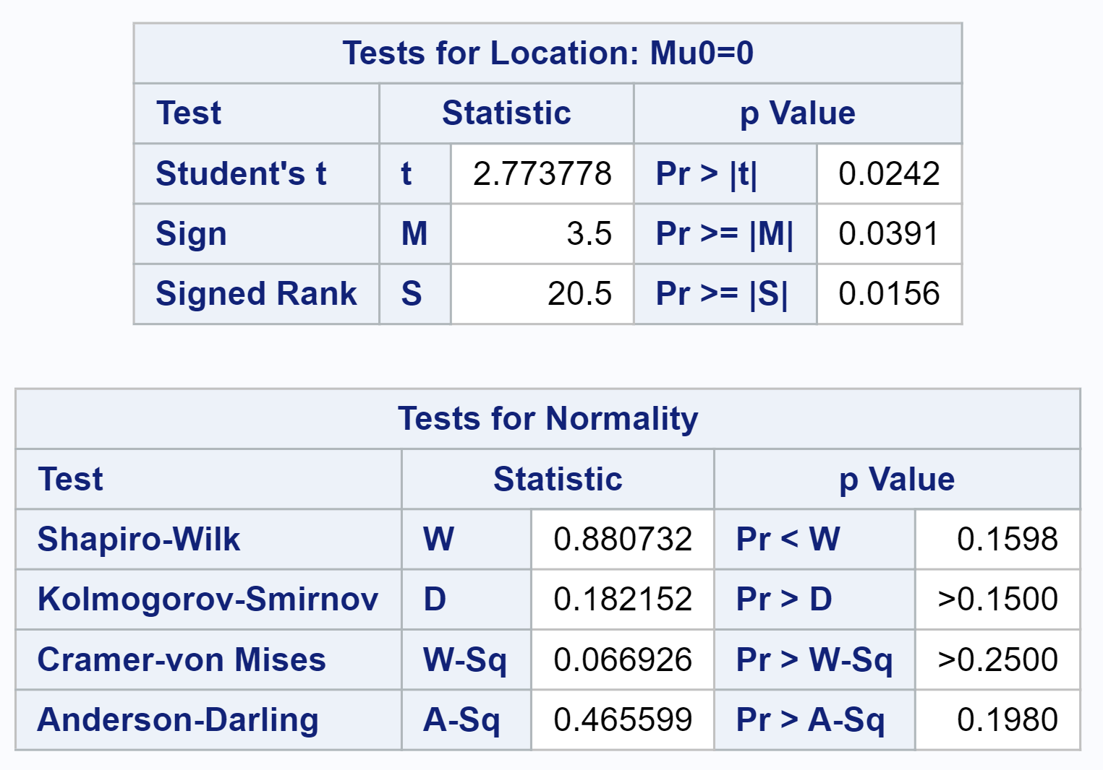

*/* 4 */*

DATA speeds;

INPUT cody smith;

Diff = cody - smith;

DATALINES;

500 355

450 388

505 440

404 600

555 510

567 501

588 502

577 489

566 499

644 489

;

PROC UNIVARIATE DATA = speeds ALPHA = 0.01 NORMAL;

VAR Diff;

RUN;

